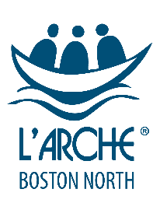

**2019**

**Annual Report**

**nn**

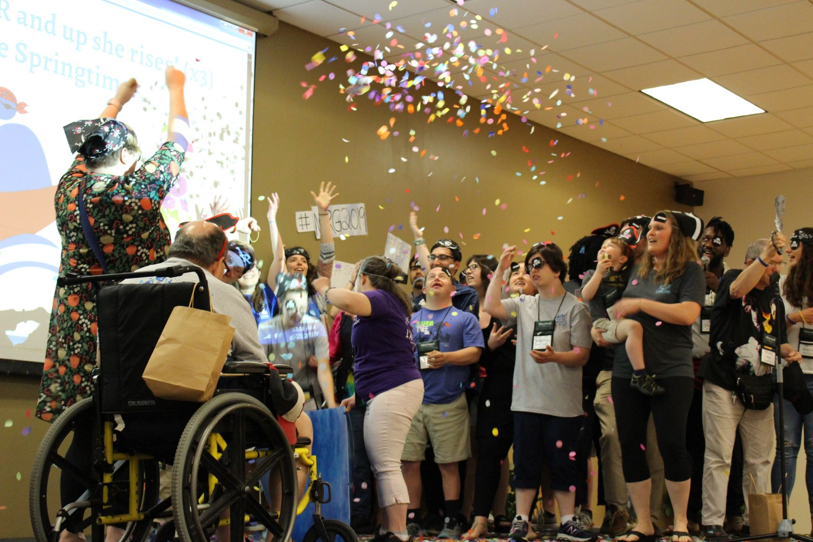

**L’Arche Boston North, Inc.**

L’Arche Boston North, Inc.

**www.larchebostonnorth.org 978-374-6928**

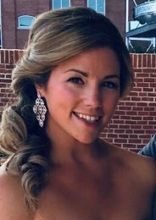**Message from Jennifer Matthews**

Dear Friends,

I am pleased to introduce the L’Arche Boston North Annual Report for 2019. Over the past year, our community has experienced some wonderful blessings, and also deep sorrow.  This has been a year for reflecting on the gifts of the past and envisioning the possibilities of the future.

With sadness and great gratitude, we have mourned the passing of L’Arche founder Jean Vanier. We continue to live his legacy and remain dedicated to his mission: that L’Arche should be a sign of hope and belonging in a world where both are so desperately needed.

We have also had the joy of celebrating 35 years as a L’Arche community with our Gala in September 2018. We recognize the friends, family, and supporters who have made it possible for us to live as a community for so many years, and we hold their stories as an important part of our community story.

As we prepare to embark on a strategic process of envisioning our mission for the next five to ten years, our current trend of positive financial standing and stability allows us to dream exciting dreams for our community’s future. We have learned many lessons in our 35 years and hope to build on the foundation of yesterday to create a larger footprint of L’Arche in the greater community today and tomorrow. We hope to develop models that reach beyond our current home-based delivery of services. In our greater community, individuals with disabilities and their families are yearning for a place of belonging, a community where they are valued and celebrated for their gifts and authenticity—in fact, for the quality of services that L’Arche provides. We envision a community where everyone has a seat at the table and is welcome, and where independence does not equal isolation. As the disability field evolves, we desire not only to meet the needs of individuals and families, but also to provide opportunities for growth and meaning in each person’s life that exceed expectations.

We need support from our friends and partners in the greater community to achieve these goals and actualize this vision for our future. We invite you to *come and see* L’Arche. Visit us for dinner or a celebration. L’Arche began over 50 years ago with one man and his simple dream to create a true home for people with disabilities. We welcome you to join us as we dare to reimagine this dream and carry L’Arche forward into the future, providing not only homes, but meaningful opportunities for belonging to all those who desire to be a part of a community where mutual relationships transform lives.

Sincerely,

Jennifer Matthews

Executive Director/ Community Leader

L’Arche Boston North

**Our Mission is to….**

**Make known** the gifts of people with developmental disabilities, revealed through mutually transforming relationships.

**Foster an environment** in community that responds to the changing needs of our members, whilst being faithful to the core values of our founding story.

**Engage** in our diverse cultures, working together toward a more human society.

**Programs**

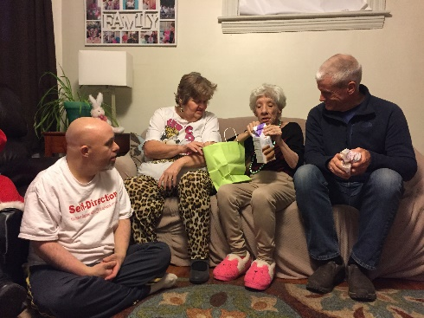**Residential Care**

24-hour extensive on-going services and supports provided to individuals who need daily intervention with care, supervision, and skills training in activities of daily living, home management, and community integration

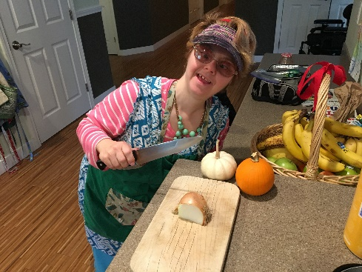**In Home Supports**

A broad range of service levels that assist clients in living as **independently** as possible within the community.

**Shared Living**

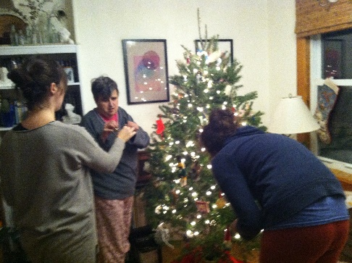Provide recruitment, placement, training, and resources forclinical or behavioral consultative services and oversight of caregivers and living situations for individuals who either live in the home of a designated care provider or live in their own homes with a designated care provider.

**Our Homes**

***“Being at home is one of the most fundamental needs of the human spirit”***

*Jean Vanier, L’Arche Founder*

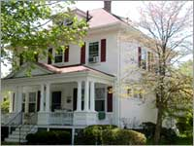Nazorean House

This is the first home that L’Arche Boston North opened in the Haverhill area. Four core members and three assistants live together in this lovely single-family home. The third floor and basement have been renovated into bedrooms for assistants. The back yard provides the community with an ideal spot for cookouts and other outdoor gatherings. The name Nazorean was chosen for this home because it was the town where Jesus lived throughout most of his childhood and as an adult until he was 30 years old.

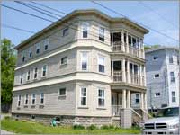Peace House

Peace House is a three-level home that has a small apartment on each of its floors and is located near the heart of downtown Haverhill. Each apartment offers independent living while giving the feeling of a one big family home throughout the three floors. Currently, a married couple live on the first floor and one core member lives on the third, all receiving minimal support. On the second floor, two core members make their home together with support from an assistant.

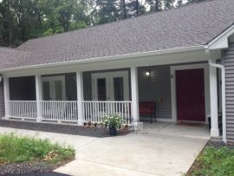Pat House

Our newly constructed, fully accessible 5- bedroom home opened September 2016 in Merrimac, MA, a town neighboring Haverhill, MA. This home has enabled us to safely and comfortably provide for our aging core members. This home has a large lot and beautiful trees surrounding the property. It has an open porch in the front and a three -season porch in the back. This home fulfills our promise to family members and guardians to provide “homes for life” for the core members in our community.

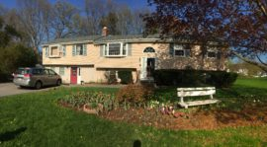Assisi House

Assisi House is a beautiful split-level home located on a quiet cul-de-sac in Bradford. Four core members and three assistants live here. With nature all around, Assisi is an appropriate name for this home – St. Francis’s home was in Assisi and he was interested in the natural world of animals and possessed a love for a peaceful life setting. The back yard of this Bradford home is a natural setting for gardening, barbecuing and just plain relaxing.

**A Loving Support System**

**Cliff Gallant**

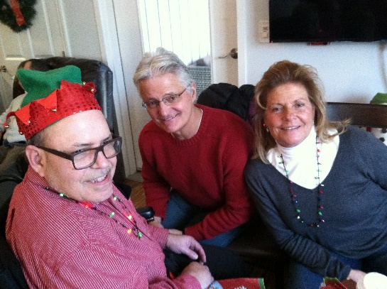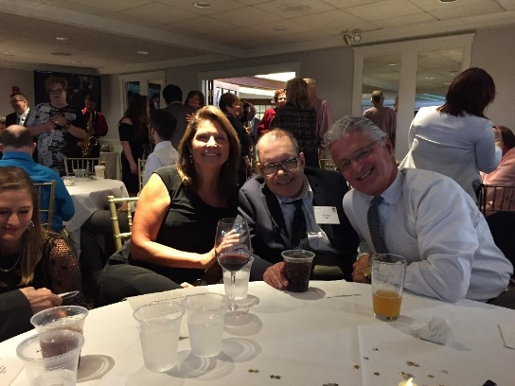Speaking for myself, I believe that L'Arche has been a godsend for Dan on multiple fronts.  As you know Dan became a core member (if memory serves me correctly) in 2004.  Dad having passed away some 5 years earlier, Mom’s ability to meet Dan's needs on a daily basis (despite all of her heartfelt efforts) became more and more difficult.  Thankfully Eleanor Sweetman introduced L'Arche to Mom.  As difficult as it was for Mom to resign herself to that reality, the L'Arche Community made the transition of Dan moving from her home into the L'Arche Community one that she realized was necessary not only for her but more importantly, for Dan.  She along with my sisters and I saw how he was welcomed into the Community and what that transition did for him.  Dan, with all the support and love of the Community, was out on his own.  Since that time, the L'Arche Community has become his extended family.  His L'Arche family has been there with and for him constantly throughout these past 15 years, being ever supportive not only in his daily activities, but in all the ups and downs life brings as well.  In the process Dan has continued to grow as evidenced by his never-ending wit and pride in doing everything he can on his own, while having come to recognize his own limitations, accepting the help of others.

*Clifford Gallant, Jr.*

*L’Arche Family Member*

**The Year in Review**

We had many wonderful experiences together over the year both individually and as a community. Here are just a few highlights!

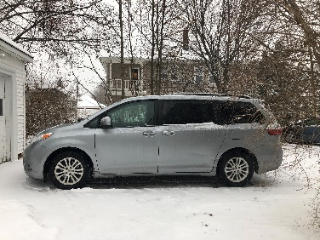**Keeping L’Arche Rolling**

Many thanks to the **George C. Wadleigh Foundation** for their generous support. With their help, we were able to purchase a new minivan for Nazorean House, ensuring that Core Members there are able to get out in the community and live active, healthy lives.

**Cummings $100K for 100—An Investment in Innovation**

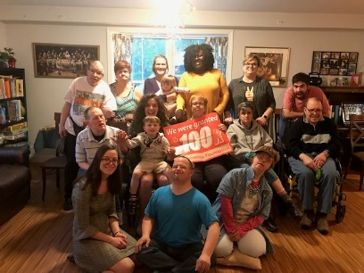We are excited to recognize the **Cummings Foundation** for their generous investment in our Homemade Hummus project. L’Arche Boston North has been awarded $25K per year over 4 years to grow this collaborative and inclusive initiative in which Core Members and Assistants together make and sell hummus at farmers’ markets and beyond.

**35th Anniversary Gala**

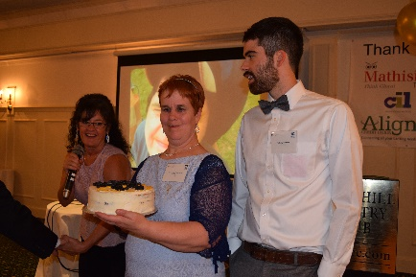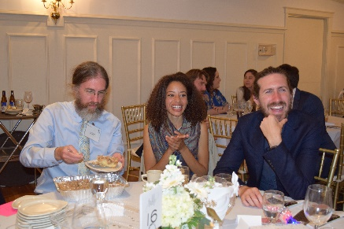L’Arche Boston North celebrated 35 years as a community with a Gala at the Haverhill Country Club in September. The evening included a cocktail hour with silent auction and Yeti raffle, a delicious meal, and a presentation on L’Arche’s impact around the world by the creators of the L’Arche International *As I Am* documentary series Michael McDonald and Amber Herkey.

The event concluded with a live dessert auction with homemade treats from community members and then after-dinner dancing. It was a beautiful evening to remember and celebrate our years as a community of L’Arche.

**L’Arche International Faith and Culture**

This winter, long-term Assistant Molly LeBlanc-Medeiros was able to travel to the Hague, the Netherlands, in the final installment of the L’Arche International Faith and Culture Program, of which she has been a part since 2016. “The opportunity to travel and experience the fellowship of a learning cohort from L’Arche communities around the world has been amazing,” Molly says. “I have learned so much about how when L’Arche is authentically present in the world, we change and the world changes—both for the better. I am very grateful to have had this chance for growth and to bring what I have learned home to my community.”

**Remembering Jean Vanier**

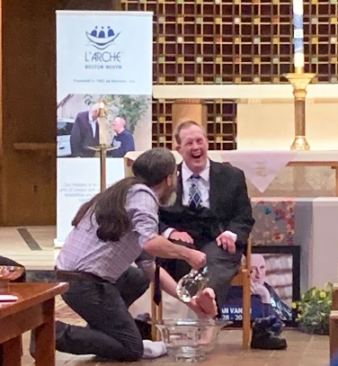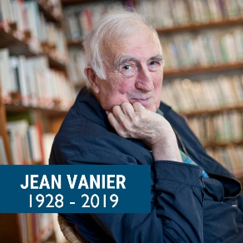On May 7, 2019, L’Arche founder Jean Vanier passed away. L’Arche Boston North honored his memory with a live-stream viewing of the funeral held in his home community of Trosly in France. Our local community members were able to share stories about encounters with Jean, inspiring more laughter than tears. The community also collaborated with Boston College to hold a memorial mass for Jean Vanier on campus. The service provided an opportunity for people from around New England to gather and give thanks for the life of a man whose legacy of love and welcome will remain an inspiration for generations to come.

**Hummus Program Expansion**

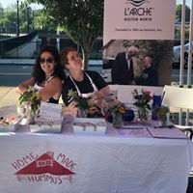This summer, the L’Arche Boston North Garbanzo Gang grew to include more Core Members and Assistants to make and sell delicious Homemade Hummus at our local Haverhill Farmer’s Market. Veteran hummus makers Emma and Christine welcomed volunteer Anthony and two new Core Members, John and Lianna, to the 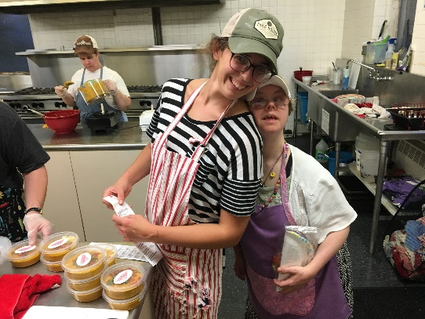team. Thanks to the welcome provided by First Baptist Church in Haverhill, the team was able to produce more hummus and sell out most weeks. Homemade Hummus is growing in popularity, and with the help of the Cummings Foundation $100K for 100 Grant, the project is poised to take the next step in expansion.

**Regional Gathering**

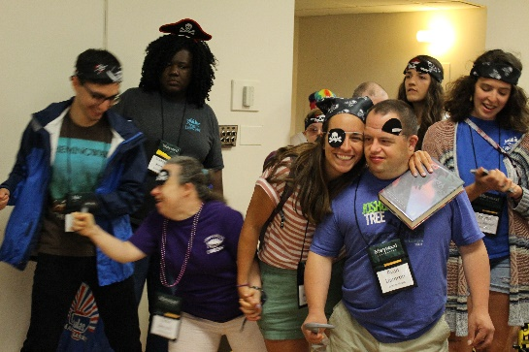This June, L’Arche Boston North community members participated in the Northeastern Regional Gathering in Scranton, PA. Every other summer, communities and burgeoning projects from the region—including Cleveland, Erie, Frederick, Greater Washington, D.C., Long Island, and Syracuse—gather to celebrate, to pray, and to meet up with old friends and make new ones. Highlights included a Community Presentation featuring L’Arche Boston North pirates and community members’ performances in the Talent Show and record-breaking sales of temporary tattoos at our Solidarity Fair table.

**A Look Ahead: The Longest Table**

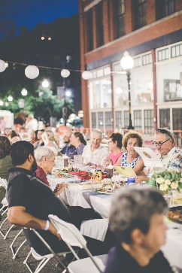In 2019, L’Arche community members began working with local partners to organize the first Longest Table event in Haverhill. The event would bring together local restaurants and sponsors to cater dinner for 200 friends and neighbors at a 300-foot- long table stretching along Wingate Street outside our main office. The Longest Table was designed to spark community conversation and help L’Arche to reach new friends and supporters by highlighting the gifts of people with and without disabilities sharing life together and building mutually transforming relationships across difference. It also created new, positive relationships for L’Arche with city nonprofits, leaders, businesses, and the police.

**The Glorious Gift of Living in the Present**

**Mary Hearon**

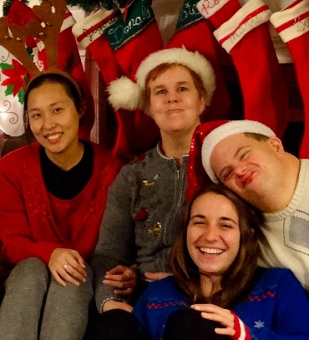My first night at L’Arche was spent around the dinner table eating, laughing, and praying in 2015 in Washington, D.C. Those moments began a journey of love and belonging that I couldn’t even begin to imagine at the time.  After graduating college, I began living in community as an Assistant in Assisi House, and throughout the last year and a half, the hopes I had for my life have been flipped on their head.  I came in as a doer, with a mission to accomplish something, because up until that point, the world had taught me to measure my worth by what I was achieving and where I was going to next.

Upon coming to L’Arche, I discovered that I was holding a deep fear that I could spend my whole life achieving and still be left restless and unhappy.  It was here that I was embraced by people with different measuring sticks than the one I knew—ones that ask me if I’m happy, if I’m feeling loved, and most importantly, what I ate for lunch.

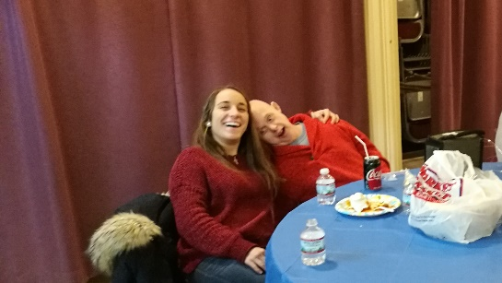

While our days are still full and we accomplish many tasks, they are approached with a sense of mutuality. We go out for coffee and attend doctors’ appointments together. We go on drives to listen to music and bake cookies to deliver to friends. We laugh when we drop things or make wrong turns, and we lend ears or a hug when someone is feeling nervous or upset.  We argue some, but forgive tenfold, embracing the grace of the present moment.  Core Members have helped me to grow in ways that allow me to rush less and look up at the world around me and see all the blessing that is there. I am so often greeting with warm welcomes into a room or embraces after time away, and it is those moments that remind me of my value as a human being, and tell me in very few words how loved and sacred I am.

L’Arche has stretched me to have a deeper understanding of the gifts that lie in the present moment and the importance of embracing each other.  It is here that I continue to learn to look up, to be awed, and to respond with love. I am confident I will carry these L’Arche life lessons with me everywhere the path may lead.

*Mary Hearon*

*Live-In Assistant, Assisi House*

**Immersion at L’Arche**

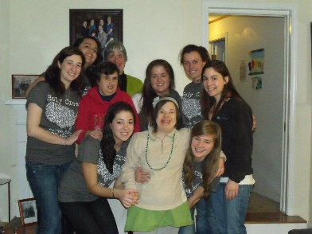At L’Arche Boston North we welcome many different organizations and schools to our community for an opportunity to immerse themselves in the world of L’Arche. We welcomed 33 volunteers from 4 different schools, logging more than 1850 volunteer hours with us throughout the year.

Following a visit from one student group, Lowell Catholic High School told us, “After talking with our students, their favorite parts of the trip were the opportunities they had to be able to interact and spend time with the core members. They thought the dance, the dinners, and the prayer time really allowed them the opportunities to get to know the core members, and, according to one student, the worst part of the trip was, ‘not knowing when we will see them again’.”

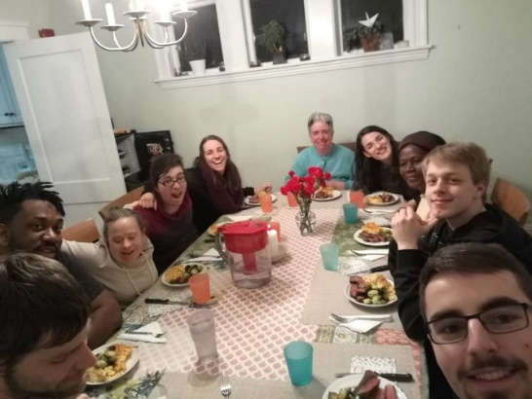**Partner Relationships**

**InVia**

We welcomed two volunteers from Invia, an organization out of Germany, who dedicated a full year with us. Florian Hellmann and Paul Wegehaupft spent their time with us supporting the homes and building relationships.

**La Salette Community**

The La Salette Community is where it all began, in the town of Ipswich, MA 35, years ago. Carole Wysopal and her husband Richard were members of the La Salette community, worshipping at the La Salette Shrine each Sunday. The Wysopals were introduced to Elizabeth Buckley, the founding director of L’Arche Scotland. Together they started L’Arche Boston North (formerly Irenicon, Inc.) La Salette continues to be a large supporter of our community. Our core members and assistants worship monthly with La Salette and we have a sitting board member from this community.**My L’Arche Is…**

**Lianna Flewelling**

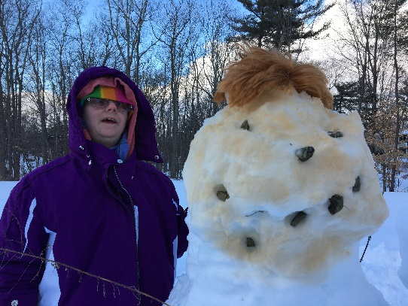

My L’Arche is basketball in the kitchen

and listening to Johnny Cash records

and honey in my tea.

My L’Arche is my bus driver’s honk outside.

My L’Arche is going to church and Dunkin

and falling asleep watching TV after work.

My L’Arche is tickling Dan

and having a hard time to know what my brain is doing.

My L’Arche is having more quality time

and wanting something to help Tom with his remix of life.

My L’Arche is *The Golden Girls*

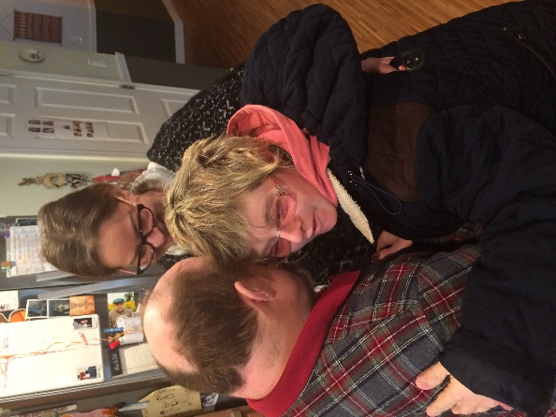 and Peace Salad.

My L’Arche is fun times

and the center of God.

My L’Arche is lighting up the night

and finding out what’s new with the Charmed Ones.

My L’Arche is doing more things with the church

and friendship growing slowly.

L’Arche is full of cherries in a bowl of us.

**Enriching Lives**

A look into our community this year!

A Night to Shine

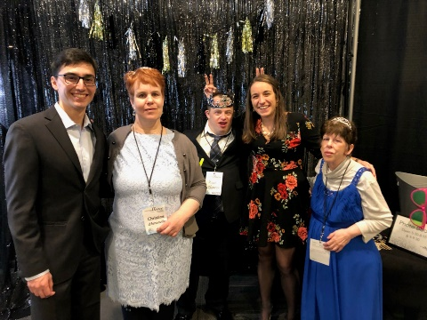 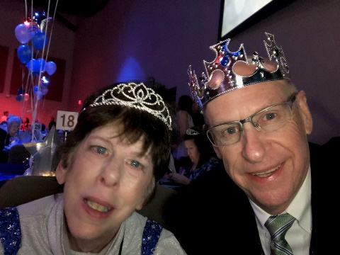 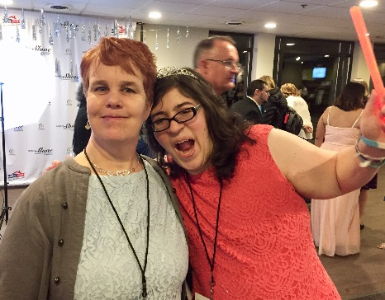

Backyard Baseball and the Red Sox at Fenway

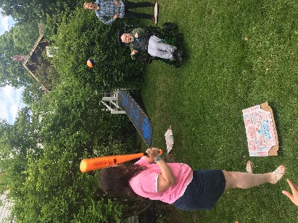 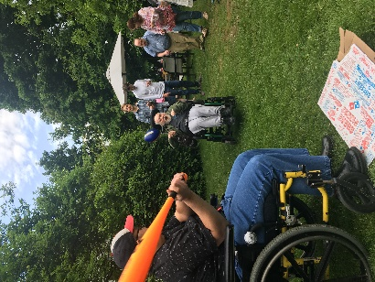 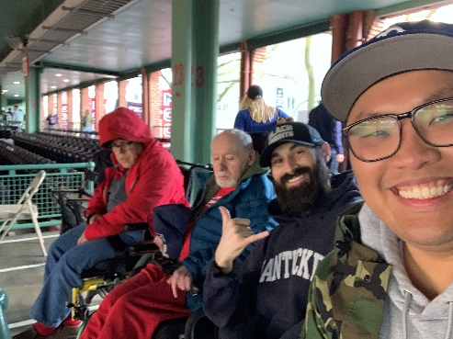

Special Olympics

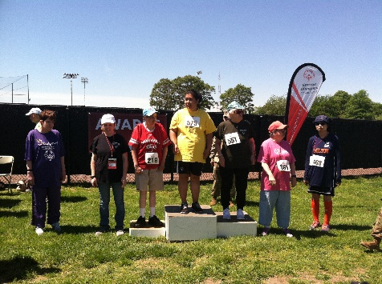 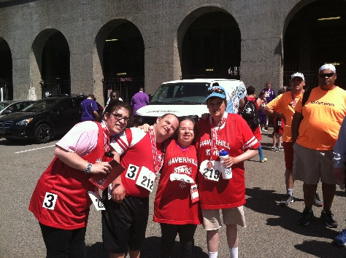 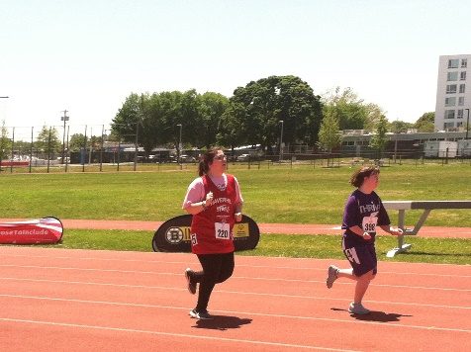

MDSC Buddy Walk for Down Syndrome 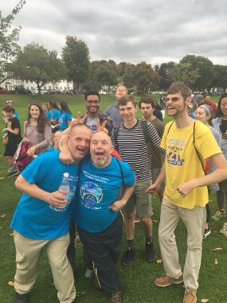 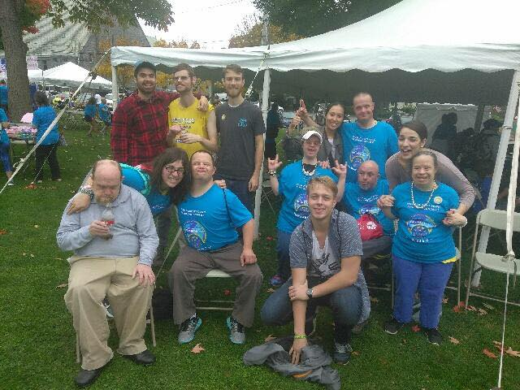

Trips to Vermont, Bermuda, and Las Vegas, as well as many other day outings.

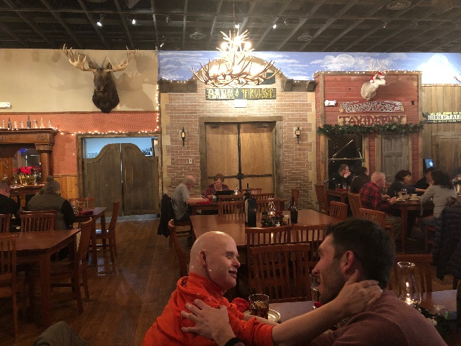 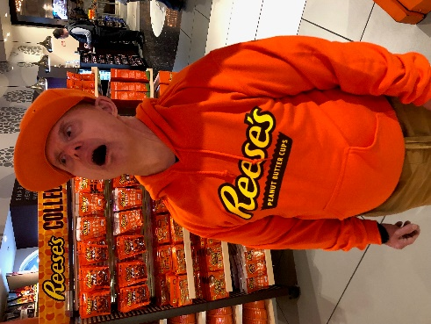 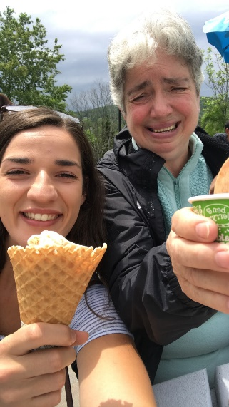

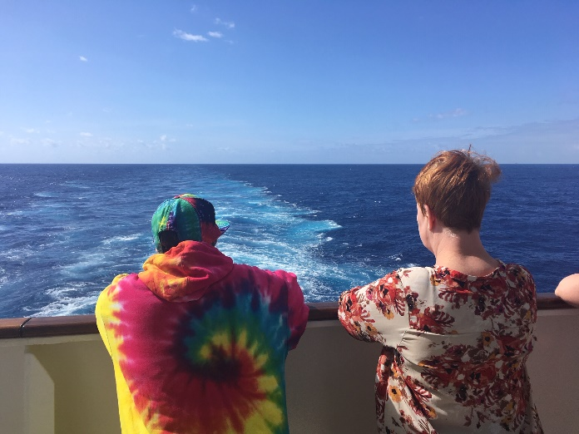 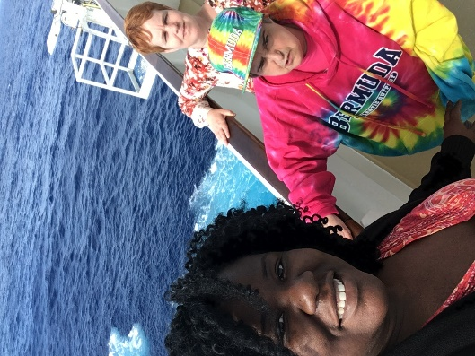

On the road, Core Members and assistants have broadened their horizons, made new friends, and learned about L’Arche communities across the country.

Other special times included special celebrations, individual accomplishments, and making memories with one another.

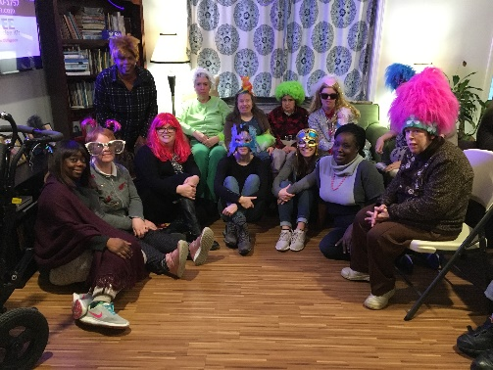 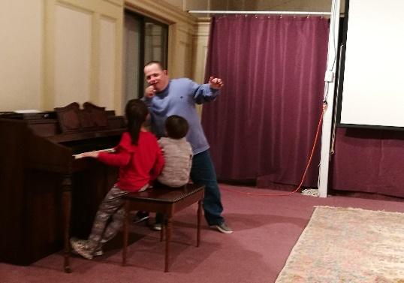 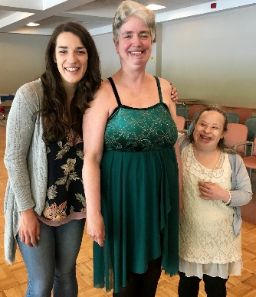

**Thank You to Our Donors**

Thank you for helping us to build a community for core members filled with rich lived experiences, countless journeys, and a life rooted in faith and spirituality.

Align Credit Union

Amazon Smile

Marie Anderson

Janice Anton

The Arc of Greater Haverhill-Newburyport

Patricia Austin

Jutta Ayer

Anthony Bachman

Ariana Bachman

Cristina Bachman

Luis & Kim Bachman

Walter Bacigalupo

Elaine Barker

James & Sheila Barry

Carolyn Beaulieu

Joseph Bevilacqua

Deborah Billington

Madelyn & Gerald Bilodeau

Peter Bolger

Barbara Booth

Boston College

Richard & Stephanie Bower

Elsie Bradway

Thomas Branch

Carole Brown

Gerry Brown

Dennis & Marie Buckley

Holly & Joseph Burke

Eileen Cadley

MaryAnne Cappelleri

CathyCarberry

Nathaniel Carpenter

Laura Castine

Amanda Chalmers

Nathan Champlin

Sandy Charland

Sandra Clark

Joseph & Susan Cleary

Frank & Annette Coccoluto

College of Holy Cross

Alice Comeau

Lawrence Comeau

Communitas, Inc.

Cooper, Kathy

Dan & Maureen Costello-Shea

Kay Crowley

Kathleen Cunningham

Lauren Curry

Robert & Carol Curry

Ellen Cushing

Suzanne D’Amonville

David Damron

Kate Daversa

Faith Delaney, Attorney at Law

Demoulas Supermarkets, Inc.

Benjamin Drayton

John & Dolores Driscoll

Donald Dupray

Elizabeth Fahey

Fidelity Charitable Fund

Christiane Flewelling

Neil Flewelling

Tammy Gagnon

Cliff & Cynthia Gallant

Don & Vicky Gallant

The GE Foundation

Give With Liberty

Karen Gralla

John & Gail Griffin

Groveland Knights of Columbus

Joy Gurrie

Adam Hamel

Joanne Harder

Christine Harrington

Nicole Harry

Haverhill Bank

Vanessa Henry

Frances Hogan

Lori Howe

Iona College

James Page Insurance Agency, Inc.

Jeanne D’Arc Credit Union

Jodi Jarvis

Jean Jennings

Ralph & Phyllis Johnson

Karen Kane

Bill & Christy Keating

Courtney Keegan

Joseph & Lauri Kennedy

Timothy & Lois Klee

Knights of Columbus

James Kuczynski

L W Bills

Stephen & Judith Lais

David & Karen Laroche

LaSalette Faith Community

Kelly Lawless

Emma Leblanc-Medeiros

Molly Leblanc-Medeiros

Sophie Leblanc-Medeiros

Carmel Leonard

Sr. Mary Elizabeth Leonard

Long Term Pharmacy Solutions

Jack Long

Philip Loring

Brittanye Mackey

Dominic & Rachel Margaglione

Masson Family Fund

Mark & Mary Masterson

Stephen Mastrocola

Carol Matsuuchi

Jennifer Matthews

Cynthia McCarthy

Edward McCarthy

John & Donna McCarthy

Patty McCarthy

Lynette McRae

Merrimacport United Methodist Church

Ronald Missick

Edward Murphy

Thomas Murphy

Donald Nason Trust

North Shore Bank

NorthEast Computer Services

Charles & Alice Odell

Barbara Ostberg

Barbara Pandolfi

Mary Papazian

Keith Patrick

Pentucket Bank

Courtney Pierce

Daniel Ponsetto

Ed & Sara Pottberg

Richard Ransom

Melissa Regan

Stephen & Susan Regan

Michael Richard

Robert Pigeon Electric

David Roberts

Hannah Robison

Roman Catholic Bishop of Boston

Rosen Law Office

Josephine Rutihinda

Sharon Ryan

Jane Ryder

Rye Senior Serve

The Sacred Hearts Parish

Salem Five

Gaylord & Nancy Salyers

Deanna Santiago

Kenneth & Marcia Savory

Shonna Scalfani

Craig & Colleen Schoeck

Edward Seaver

William & Elaine Shea

Robert & Joan Shea

Sisters of Charity Halifax

Sheila Skane

Mary Kate Small

Jodi Smith

St. John’s Community

St. Joseph’s Abbey

Judith Stanley

Maureen Stillwell

Karen Stone

Stonehill College

Stephen & Karen Stulck

Marilyn Suszek

Eleanor Sweetman

Brian & Sue Testa

Shannon Thompson

Maureen Thorley

Richard & Anne Tonachel

Town of Groveland

The Wadleigh Foundation

Susan Wagner

Ruth Wall

Jessica Wallace

Walsh & Company

Michael Walsh

Suzanne Wasileski

West Congregation Church

Jeff & Cindy White

Caroline Wong

Chris & Deb Wysopal

Terrence Zecha

**Thank You to Our Donors**

**“Change the world with love, one heart at a time.”**

*Jean Vanier, Founder of L’Arche*

*This is a list of those who have supported us financially from July 1, 2018 through June 30, 2019. Sincere efforts have been made to assure the accuracy of these donor records. We apologize for any errors or omissions and ask you to notify us with corrections to help us continue to improve our efforts.*

Financial Snapshot Fiscal Year 2018-2019

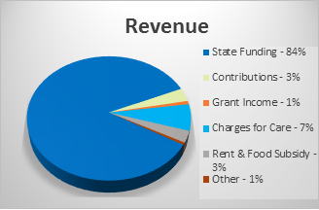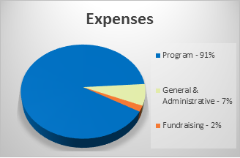

Full audited financial statements and form 990 available on our website.

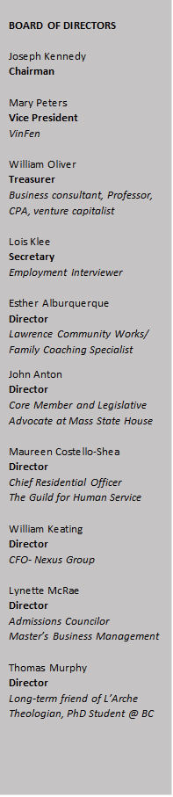**We Need Your Help**

Please consider being a partner in our mission and supporting us to provide a community for Core Members filled with rich lived experiences, countless journeys, and a life rooted in faith and spirituality.

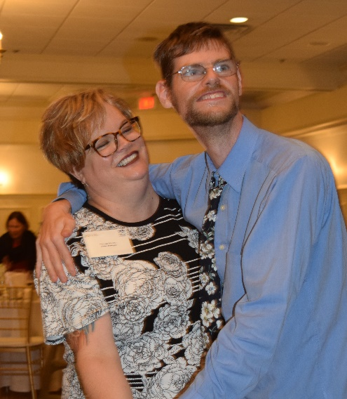**You Make a Difference**

Please visit us at larchebostonnorth.org to make your secure online donation or you can send it by mail to:

*L’Arche Boston North, Inc. PO Box 1177, Haverhill, MA 01831*

**Volunteer and Impact Lives**

We welcome, delight in and depend on volunteers of all ages, from students to retirees.

We are in need of people with special trades or expertise in helping us with routine repairs and maintenance of our homes. Please contact our office if you would like to donate some time!

**4 SCHOOLS**

**33 VOLUNTEERS**

**1850 HOURS**

**NOTHING IS AS STRONG AS THE HEART OF A VOLUNTEER**

special thanks to

Cristo Rey High School, College of the Holy Cross, Iona College, and Stonehill College

L’Arche Boston North, Inc.

PO Box 1177

Haverhill, MA 01831



Address Block

Main Office

53 Wingate Street

Haverhill, MA 01831

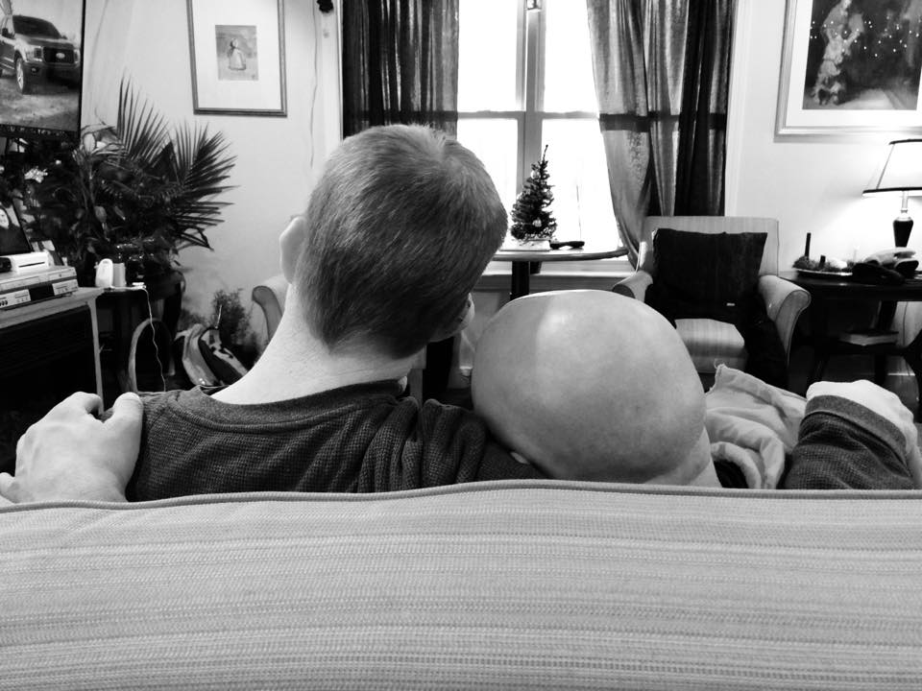

Assisi House

9 Sussex Street

Bradford, MA

Nazorean House

73 Lamoille Ave

Bradford, MA

Peace House

55-57 Ninth Ave.

Haverhill, MA

**JOIN US**

We love visitors! We have many opportunities for you to get to know us. Join us at our monthly Anniversary and Birthday celebrations or for a prayer night. Learn what life in our homes is like and visit for dinner or a special event. Call our office to learn more!

Pat House

9 Valley Street

Merrimac, MA