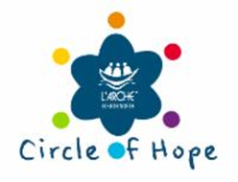

Thank you for joining the L’Arche Boston North Circle of Hope! As a monthly donor, you can know that your contribution is making a difference in the lives of our community members by providing both ongoing financial security and a relationship with our community. Thank you for being one of us!

Circles of Support

Supporter
$10-29/month

Sustainer
$30-$49/month

Advocate
$50-$99/month

Champion
$100/month and up

Donor Name _________________________________________

Address _____________________________________________

City ________________________ State _______ Zip _________

Phone ______________ Email ____________________________

Please accept a recurring monthly donation of $________ on the ____ (1st, 15th, etc.) of every month
Please make checks payable to L’Arche Boston North.

Circle of Support Level __________________________________

Signature _____________________________________________

L’Arche Boston North is a 501(c)3 non-profit under IRS rules—all donations are tax-deductible.
Acknowledgement letters are sent to all donors for tax purposes.

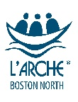
P.O. Box 1177 ° Haverhill, MA 01831
978-374-6928 ° Fax 978-973-9097 °www.larchebostonnorth.org

